Walk 50 Kyrle-on-Wye
Last walked in October 2018

Description. 5.3 km (3.3 miles). An easy walk through suburban streets, woodland and along riverside paths. No stiles.
Start. Park in the car park by the river. Explorer Map 189 Grid 594239.
Direction from Belmont roundabout (Turn milometer to zero). Follow the A49 to Ross-on-Wye and at 12.8 miles you go straight across the roundabout for Ross-on-Wye, and a little further on, at 13.2 miles you TR into the car park.

1. Car Park. At the back of the car park, behind the skate-boarding area. Cross the footbridge, bear slightly L as you go up to the top of the steep hill, (path may be blocked by large fallen tree). Further up the path gets more distinct. Go up a number of steps to reach a T-junction, TR, you are now walking along a level path called ‘The John Kyrle Walk, an iron railing fence is on your R. Go thru a k-gate into a field and continue along the R edge. Continue along the R edge of field 2. Near the field end the path bears off slightly R. Go thru a k-gate and down to descend some steps to reach a sign posted track junction in a hollow. TL. Continue on, to go thru a large k-gate and along an enclosed track that becomes a tarmac path, emerging by a house called The Cleeve. TL, walk along this lane to reach a road. Go straight across and continue along an enclosed path beside houses. Keep on this alleyway for about ½ km as it crosses several residential streets, to reach a disused railway line that’s more a dirt track, (just before reaching the path junction and on the R side is a field; houses are in front of you; a sign post saying: Please take your litter home, to deposit it here is an offence, penalty £100). TL, walk along the disused railway line, that’s decorated with trees and occasional picnic tables, to reach the main B4234 road. Straight across a lighted road crossing and along an enclosed track, to reach Fernbank Road, (a car park is directly in front of you). TR and walk up Fernbank Road. Keep straight ahead, ignoring Woodmeadow Road (R). The road becomes a track, and rises steadily, entering Chase Wood.

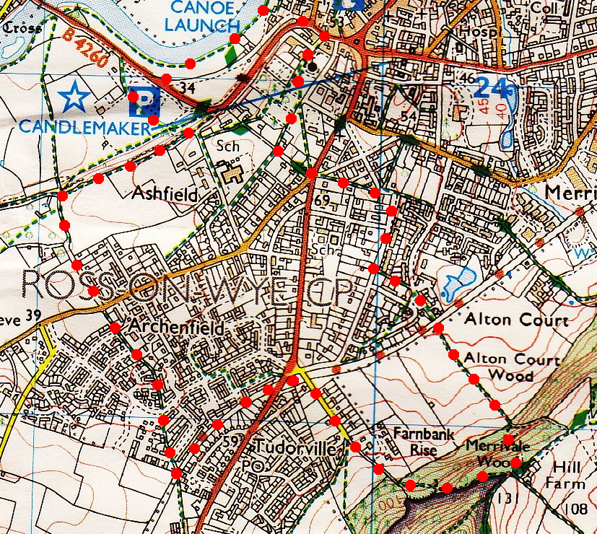
2. Hill Farm. Bear L just before reaching the buildings of Hill farm, and go thru a metal gate and on a descending path, (Hill farm buildings are in front of you, very near to the top of the hill). After about 30m you take the left fork, to soon descend on a steep stepped path. Continue down and at the bottom you reach a T-junction. TR, and when you reach a k-gate you TL into a field and follow the R field edge down. Cross the disused railway again, and continue down an alleyway and a cul-de-sac to reach Merrivale Lane. TR, and immediately cross the road to walk up a very narrow alleyway that’s beside an electricity sub station to reach another road, where you TR. Walk to the end of this road (The Avenue) that further up bends L. At the end of The Avenue TR, then immediately TL into Ashfield Crescent. Walk down to the cross roads and TR. At the next cross roads you go straight across, along along Redhill Road. Go past Ashfield Park Avenue (R) and the primary school entrance (R) to continue in the same direction along an enclosed path. On reaching iron railing by a way marker sign post, you TR along Buggy Route and John Kyrle Walk, (here you are not many paces from a point on the outward walk). Take the fenced path beside the school's playing fields, and continue on to reach the large churchyard. Continue in the same direction. Directly in front of you is a tall brick wall and an iron gateway that you have to go thru. Getting to the gateway and into the enclosure means going around, or straight thru a few graves. Have a good look around the enclosure, called The Prospect.
1
3

3. Gateway. Leave The Prospect by the gateway close to St Mary's Church. John Kyrle was buried in the chancel here. Leave the church grounds by the main entrance, (over in the bottom R hand corner) passing the fine, sandstone Rudhall's Almshouses (1575). TL into Church Street, then L at a T-junction and walk to the end of High Street. Cross the road and pass in front of the Man of Ross public house (R) (the plaque in front of it describes the 18th-century problems of muddy streets). Descend steps to reach the river beside the Hope and Anchor pub. TL. (Here the wheel for pumping water up to the town once stood.) Follow the riverbank, passing a number of benches and bearing L across the grass to go past a metal statue of two birds. Continue on to cross over the main road ahead, and into the car park.
2

